ANSWER

COMPOSITE:-
Two or more chemically different constituents combined macroscopically to yield a useful material. Composite materials are materials made from two or more constituent materials with significantly different properties, that when combined, produce a material with characteristics different from the individual components. Composite materials consist of two or more chemically distinct constituent on a macro scale having a dispersed interface separating them and having bulk performance which is considerably different from those of any of its individual constituents.

Examples, of naturally occurring composites permeated with holes filled with liquids: -

Wood: Cellulose fibers bound by lignin matrix.
Bone: Stiff mineral “fibers” in a soft organic matrix permeated with holes filled with liquids.
Granite: Granular composite of quartz, feldspar, and mica.

Some examples of man‐made composites.

a.Concrete: Particulate composite of aggregates (limestone or granite), sand, cement and water.
b. Plywood: Several layers of wood veneer glued together.
c.Fiberglass: Plastic matrix reinforced by glass fibers.
d.Cemets: Ceramic and metal composites.
e.Fibrous composites: Variety of fibers (glass, kevlar, graphite, nylon, etc.) bound together by a polymeric matrix.
A composite material is made by combining two or more materials– often ones that have very different properties.
Composites are mainly composed of fiber and matrix material composition composite and the necessary properties required for fiber and matrix material for development of required composite material.

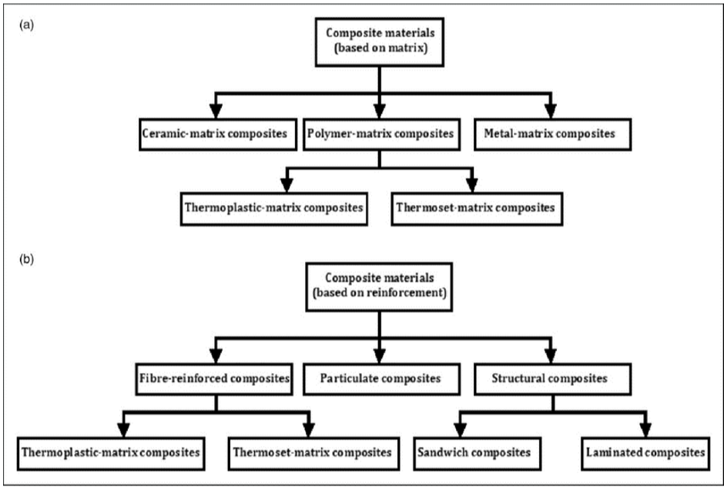

FIBER AND MATIX MATERIAL
Fabric is made of fibers. Fiber or fibre is a natural or synthetic substance that is significantly longer than it is wide. Fibers are often used in the manufacture of other materials. The strongest engineering materials often incorporate fibers, for example carbon fiber and ultra-high-molecular weight polyethylene. Synthetic fibers can often be produced very cheaply and in large amounts compared to natural fibers, but for clothing natural fibers can give some benefits, such as comfort, over their synthetic counterparts. Fibers are made of twisted filaments.

Types of fibers and fabric:
Natural— Natural fibers develop or occur in the fiber shape, and include those produced by plants, animals, and geological processes. They can be classified according to their origin:

Vegetable fibers are generally based on arrangements of cellulose, often with lignin: examples include cotton, hemp, jute, flax, ramie, sisal, bagasse, and banana. Plant fibers are employed in the manufacture of paper and textile (cloth), and dietary fiber is an important component of human nutrition.

Wood fiber, distinguished from vegetable fiber, is from tree sources. Forms include groundwood, lacebark, thermomechanical pulp (TMP), and bleached or unbleached kraft or sulfite pulps. Kraft and sulfite (also called sulphite) refer to the type of pulping process used to remove the lignin bonding the original wood structure, thus freeing the fibers for use in paper and engineered wood products such as fiberboard.

Animal fibers consist largely of particular proteins. Instances are silkworm silk, spider silk, sinew, catgut, wool, sea silk and hair such as cashmere wool, mohair and angora, fur such as sheepskin, rabbit, mink, fox, beaver, etc.

Mineral fibers include the asbestos group. Asbestos is the only naturally occurring long mineral fiber. Six minerals have been classified as "asbestos" including chrysotile of the serpentine class and those belonging to the amphibole class: amosite, crocidolite, tremolite, anthophyllite and actinolite. Short, fiber-like minerals include wollastonite and palygorskite.

Biological fibers also known as fibrous proteins or protein filaments consist largely of biologically relevant and biologically very important proteins, mutations or other genetic defects can lead to severe diseases. Instances are collagen family of proteins, tendon, muscle proteins like actin, cell proteins like microtubules and many others, spider silk, sinew and hair etc.

Example: - Animal, vegetable, or inorganic

Artificial—Human-made or chemical fibers are fibers whose chemical composition, structure, and properties are significantly modified during the manufacturing process. Man-made fibers consist of regenerated fibers and synthetic fibers.

Example: Rayon, Nylon, Acetate, Acrylic, Spandex, Polyester Semi-synthetic fibers.

Semi- synthetic fibers are made from raw materials with naturally long-chain polymer structure and are only modified and partially degraded by chemical processes, in contrast to completely synthetic fibers such as nylon (polyamide) or dacron (polyester), which the chemist synthesizes from low-molecular weight compounds by polymerization (chain-building) reactions. The earliest semi-synthetic fiber is the cellulose regenerated fiber, rayon. Most semi-synthetic fibers are cellulose regenerated fibers.

Cellulose regenerated fibers
Cellulose fibers are a subset of man-made fibers, regenerated from natural cellulose. The cellulose comes from various sources: rayon from tree wood fiber, Modal from beech trees, bamboo fiber from bamboo, seacell from seaweed, etc. In the production of these fibers, the cellulose is reduced to a fairly pure form as a viscous mass and formed into fibers by extrusion through spinnerets. Therefore, the manufacturing process leaves few characteristics distinctive of the natural source material in the finished products. Synthesized or created from altered natural sources.

MATRIX MATERIAL
While the principal strength and stiffness of the composite is provided by the fibres, the matrix material also has a large part to play in the overall mechanical properties. The matrix is not designed to bear much of the load. Instead, the matrix binds the fibres together and distributes the load. It also provides ductility and protects the fibres from surface damage. It separates the fibres and prevents propagation of cracks from one fibre to the next. Also, unless the matrix chosen is a particularly flexible one then it will assist in prevention of the fibres buckling under compression.

The requirements of a good matrix material are that it can infiltrate between the fibres and form a strong interfacial bond. It is also essential that there is no chance of chemical reaction between the matrix material and fibres and that the matrix material does not cause damage to the fibres.

There are three main types of composites based on the type of matrix they employ –

1. polymer matrix composites (PMC)
2. ceramic matrix composites (CMC) and
3. metal matrix composites (MMC).

The most common type are polymer matrix composites. They are produced in the largest quantities, due to their good room temperature properties, ease of manufacture and low cost.

Fibers and whiskers in composites are held together by a binder known as matrix. This is required since fibers by themselves:

Matrix material serves several functions, the important ones being:
i) Binds fibers together.
ii) Transfers loads and stresses within the composite structure.
iii) Support the overall structure
iv) Protects the composite from incursion of external agents such as humidity, chemicals, etc.
v) Protects fibers from damage due to handling.
vi) Matrix material also significantly limits a composite’s maximum permissible operating temperature.
vi) Most of the matrix materials are relatively lighter, more compliant, weaker vis‐à‐vis fibers & whiskers.
vii)However, the combination of fibers/whiskers and matrix can be very stiff, very strong, & yet very light.
viii) Thus, most of modern composites have very high specific strengths, i.e. very high strength/density ratios.
ix)This makes them very useful in aerospace applications, where weight minimization is a key design consideration.

THERMOSETTING AND THERMOPASTIC POLYMER
Thermosetting plastics: -
1. Thermosets have qualities such as a well-bonded three-dimensional molecular structure after curing.
2. This polymer is hard and infusible on heating.
3. These are not soft on heating under pressure and they are not remolded.
4. These polymers are cross linked or heavily branched molecules
5. These polymers we cannot reused or recycle.

Ex. Some common examples are Bakelite, urea-formaldehyde resins etc.

Thermoplastic polymers: -
1. These are the polymers having intermolecular forces between elastomers and fibers.
2. They are those polymers which can be softened on heating & hardened on cooling room temperature.
3. They may be linear or branched chain polymers.
4. These polymers can be recycled many times. Ex, Polythene, polyesterne, PVC.

MANUFACTURING METHODS FOR FIBER MATERIAL
1. Manufacturing of cotton: -
Cotton is obtained plant source and it is classified as a natural material as it is obtained from the seeds of cellulose seed fibre staple fibre measuring 10-65mm in length and white to beige in color in its natural state. It is composed basically of a substance called cellulose. As cotton occupies 50% of the consumption of fibres by weight in the world it is called as the king of all fibres.

Cotton is the fabric for every home and is the most widely produced of textile fabrics today. It has now been proved that India was the first country to manufacture cotton. Among the recent findings at Mohenjo-Daro were a few scrapes of cotton sticking to the side of a sliver’s vase. Cotton is thewhite downy covering of the seed grown in the pods. The cotton plant grown in the tropics needs a climate with 6 months of summer weather to blossom and produce pods.
Manufacture of machine-made cotton: -
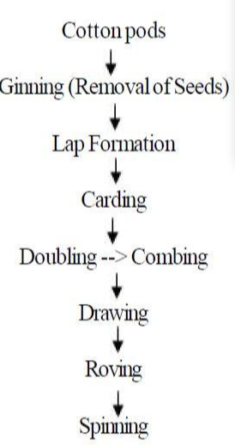
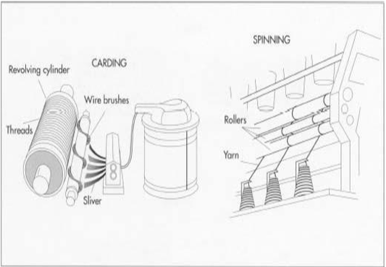
Fig. 1.3 Machine made cotton

2. Manufacture of protein fibres: -
This unit gives us the information regarding the manufacture of physical and:- chemical properties of protein fibres.

(1) Silk (2) Wool
Silk is considered as “Queen of all textile fibres” as it has beauty and elegance and good properties of performance. Silk is the natural protein fiber obtained from silk worm cocoons. Japan is known for producing best variety of silk.

India produces different varieties of silk and is famous for hand woven silk textiles. There is a tremendous silk production increase in recent years. The production of silk is called Sericulture. To obtain quality and quantity of silk rearing conditions are controlled carefully throughout the life cycle of silk moth.

These are two types of silk mulberry or cultivated silk and wild silk. Cultivated silk is creamy silk white or yellowish white in color. White wild silk color ranges from brownish to golden yellow in color.
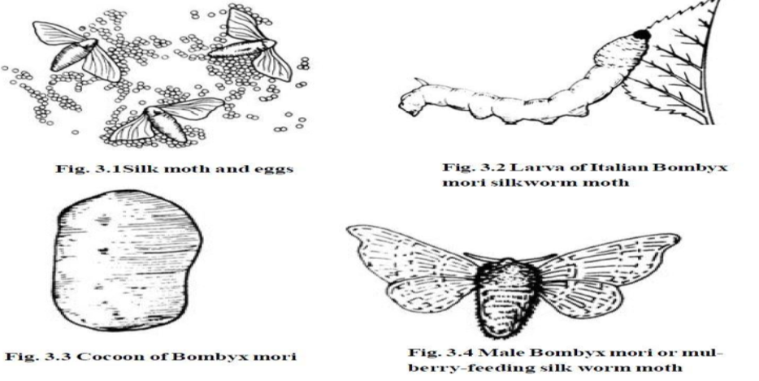
Fig. 1. 4 Production of silk

4. Production of wool: -
Wool has the one of the first fibres to be converted into fabric. Wool fibre grows from skin of sheep. It is composed of protein known as keratin. It is crimp and has scales on its surface depending upon the breed of sheep.

The natural protein fibre consist of amino acids. Wool has 19 amino acids, keratin, protein and other organic acids. Man uses wool as clothing in the very early stages of human history. The primitive man is used it in the form of skin of certain animals to protect as well as to decorate his body. Man, then discovered the use of hair of sheep after interlocking and twisting them together under pressure and thus hair of sheep was used in making fabrics the interlocking of woolen fabrics is known as felting.
Wool was probably known to the primitive man as he used sheep skin to cover his body even before the discovery of other fibres.

Wool is yellowish white fibre and has medium luster. It is considered to be weak fiber than many other fibres however other properties such as resiliency and elasticity compensate for low strength.

Shearing:- Sheep are generally shorn of their fleeces in spring but the time of shearing differs in different parts of the world. Machine clippers remove the fleece faster and closer than hand clippers. Superior wool variety comes from the sides and shoulders where it grows longer, finer and softer is treated as good quality fleece.

Preparation:- An average about 8 pounds of fleece is made from one sheep. Then the fibers are packed in bags or bales. The raw wool or newly sheared fleece is called Grease wool because it contains the natural oil of the sheep. When Greese wool is washed, it loses from 20 to 80% of its original weight.
Sorting and grading: - Skilled workers do wool sorting. Each grade is determined by type, length, fineness, elasticity and strength. Separating of fibre by touch and sight.
Scouring: - Washing of raw wool is an alkaline solution is known as scourcing. The wool is treated with warm water, soap, mild solution of soda ash or other alkali to remove dirt in the fibres. If the raw wool is not sufficiently clear of vegetable, substance after scouring is put through the carbonizing bath. The fibres are then put through a dilute solution of sulphuric or hydrochloric acid which destroys any vegetable.

Garnetting:- Recycled wool fibres are obtained by separately reducing the unused and used fibrous mass by a picking and shredding process called garneting.

Drying: Wool is not allowed to become absolutely dry usually about 12 to 16% of moisture is left in wool to condition it for subsequent handling.

Oiling: As wool is un manageable after scouring the fibre is usually treated with various oils including animals, vegetable, mineral or a blend of these to keep it from being becoming brittle or lubricate it for the spinning operation.

Dyeing: If the wool is to be dyed in raw stock it is dyed at this stage. Some wool fabrics piece dyed, some are yarn or skin dyed and some are top dyed.

Blending: Wool of different grades or pure wool fibres and other textile fibers may be blended mixed together at this point.

KELVAR FIBER :-
Kevlar is a registered trademark for a synthetic fiber produced by DuPont, a chemical company. Kevlar was developed in 1965 and being used commercially since 1970. DuPont can also be credited for the development of other polymers such as Neoprene, Nylon, Teflon, Nomex etc.

Chemical name for kevlar is poly-para-phenylene terephthalamide.
i) Kevlar is a polymer
ii) Kevlar is a high strength material
iii) It is very light when compared to its strength
iv) It is 5 times stronger than steel of same weight
v) It has very high tensile strength
Thus, it can be said as a Super strong plastic

Kevlar is a polymer chain with cross linkages which having high strength. The hydrogen bonds also strengthen the bonds.

Types of Kevlar

Although Kevlar is main product, there are various other grades of Kevlars produced
1. Kevlar
2. Kevlar K29
3. Kevlar K49
4. Kevlar K100
5. Kevlar K119
6. Kevlar K129
7. Kevlar AP
8. Kevlar XP
9. Kevlar KM2

Properties: -
1. Strength to weight ratio is more
2. Withstands temperatures upto 450⁰C and as low as -196⁰ C
3. Self-extinguishable
4. Resistant to almost all types of chemicals
5. Negative co-efficient of thermal expansion
6. Abrasion resistance

CARBON AND GRAPHITE FIBERS
Carbon Fiber's reputation as a material has taken on mystical proportions! Not only does it have a reputation for being the best and the strongest, but it's also become cool to have something made of carbon fiber.

Carbon Fibre, not surprisingly, is made of carbon crystals aligned in a long axis. These honeycomb shaped crystals organize themselves in long flattened ribbons. This crystal alignment makes the ribbon strong in the long axis. In turn these ribbons align themselves within fibers. The fiber shape is the original shape of the material (its precursor) used to produce the Carbon Fiber. I don't know of any process where fibers are shaped after carbonizing. These fibers (containing flat ribbons ofcarbon crystals) in turn are bundled by the manufacturer in thicker fibres and are woven into carbon cloth, made into felt, twisted or bundled without twisting. This is referred to as Roving. Carbon fiber is also offered as chopped strands and powder.
Properties of carbon fibre:
1. High Strength to weight ratio
2. Rigidity
3. Corrosion resistance
4. Electrical Conductivity
5. Fatigue Resistance
6. Good tensile strength but Brittle
7. Fire Resistance/Not flammable
8. High Thermal Conductivity in some forms
9. Low coefficient of thermal expansion
10. Non-poisonous
11. Biologically inert
12. X-Ray Permeable
13. Relatively Expensive
14. Requires specialized experience and equipment to use

SURFACE TREATMENT OF FIBER MATERIAL
This review is based on the surface treatment of natural fibres which can be used in technical applications. Natural fibres on their own have some draw backs regarding moisture uptake, quality variations, low thermal stability, and poor wettability. Insufficient adhesion between polymer matrix and fibre leads in time to debonding. Overcoming the weaknesses of these natural fibres gave the motivation for this study where physical and chemical methods of modification were considered.

Physical methods such as electric discharge and mercerization were reported as well as the chemical methods such as graft copolymerization and treatment with isocyanates, and the results due to these modifications were discussed. This study reveals that natural fibres are good candidates for reinforcement but they have to be suitably treated to improve their properties if they are to be used in technical applications. The various fibre surface treatments actually improve the interfacial adhesion between the fibre surface and the matrix, thereby giving good mechanical properties to the resulted polymer composites.

Physical Methods
Physical methods such as stretching, calendaring, thermo treatment and the production of hybrid yarns do not change the chemical composition of the fibres but however they change the structural and surface properties of the fibre and thereby influence the mechanical bonding to polymers.

Other ways of treating fibre surface using physical method could be electric discharge such as (corona, cold plasma). Corona treatment is one of the most interesting techniques for surface oxidation activation. It is a process that changes the surface energy of the cellulose fibres and in case of wood surface activation increases the amount of aldehyde groups. Depending on the type and nature of the gases used, a variety of surface modification could be achieved by using cold plasma treatment which will in turn introduce surface crosslinking while surface energy could be increase or decrease and reactive free radicals and groups could be produced.

Electric discharge methods are known to be very effective for ‘‘non-active’’ polymer substrates as polystyrene, polyethylene, polypropylene, etc. They are successfully used for cellulose-fibre modification, to decrease the melt viscosity of cellulose-polyethylene composites and improve mechanical properties of cellulose-polypropylene composites.

There is also a physical method called mercerization, this is actually an old method used in modifying cellulose fibre, it has been widely used on cotton materials.

Corona treatment (sometimes referred to as air plasma) is a surface modification technique that uses a low temperature corona discharge plasma to impart changes in the properties of a surface. The corona plasma is generated by the application of high voltage (15KV) to an electrode that has a sharp tip. The plasma forms at the tip. A linear array of electrodes is often used to create a curtain of corona plasma. Materials such as plastics, cloth, or paper may be passed through the corona plasma curtain in order to change the surface energy of the material. All materials have an inherent surface energy.
The corona treatment was invented by the Danish engineer Verner Eisby in 1951.
Many plastics, such as polyethylene and polypropylene, have chemically inert and nonporous surfaces with low surface tensions causing them to be non-receptive to bonding with printing inks, coatings, and adhesives. Although results are invisible to the naked eye, surface treating modifies surfaces to improve adhesion.

Polyethylene, polypropylene, nylon, vinyl, PVC, PET, metalized surfaces, foils, paper, and paperboard stocks are commonly treated by this method. It is safe, economical, and delivers high line speed throughput. Corona treatment is also suitable for the treatment of injection and blow molded parts, and is capable of treating multiple surfaces and difficult parts with a single pass.

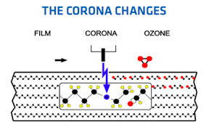

a) EPOXIES :-
Found by C. Castan in 1930s on his search for dental use and successfully introduced by Ciba (Central Institute of Brackishwater Aquaculture) by end 1940s in the electro industry as insulating material, as coating and laminating material, as well as adhesive.

Also called "epoxy" or "polyepoxide".

Second most widely used family of thermosets copolymer (after polyesters)
Large portion of uses are non-reinforced (adhesives, paints, etc.)
Circuit boards are the largest reinforced application (low conductivity, low volatiles)

General properties: -
i) High Mechanical Properties: large cohesive force.
ii) Good Adhesive Performance: great number of polar groups.
iii) Excellent stability: without impurities (base and salt).

Properties of epoxy rasins: -
1. Chemical stability – due to ether linkage.
2. High reactivity – epoxy/ hyroxyl group.
3. Excellent adhesion to surface.
4. Outstanding electrical properties – industrial application.
5. Ability to form co-polymer with various polymer.

b) PHENOLIC :-
Phenolic give highly cross-linked polymers. Phenol formaldehyde was the first synthetic plastic and is known as Bakelite. The polymer is opaque and initially light in colour, it does, however, darken with time and so is always mixed with dark pigments to give a dark-coloured material. Itis supplied in the form of a moulding powder which includes the polymer, fillers and other additives such as pigments. When this moulding powder is heated in a mould the cross-linked polymer chain is produced. The fillers account for some 50-80% of the total weight of the moulding powder. Wood flour which is a very fine softwood sawdust, when used as a filler increases the impact strength of the plastic, asbestos fibres improve the heat properties, and mica the electrical resistivity. The following table shows some of the properties of this thermoset. Phenol formaldehyde mouldings are used for electrical plugs and sockets, switches, door knobs and handles, camera bodies and ash trays.
Amino-formaldehyde materials, gernally urea formaldehyde and melamine formaldehyde, give highly cross-linked polymers. Both are used as moulding powders with cellulose and wood flour widely used as fillers, hard, rigid, high-strength materials are produced with the following table showing some of the properties. Both materials are used for tableware knobs, handles, light fittings and toys.

Epoxide materials are thermosets which are generally used in conjunction with glass fibers to give hard and strong composites. Polyesters cam be produced as either thermosets or thermoplastics. The thermoset form is mainly used with glass fivers to form hard and strong composite; such composites are used for boat hulls, architectural panels.

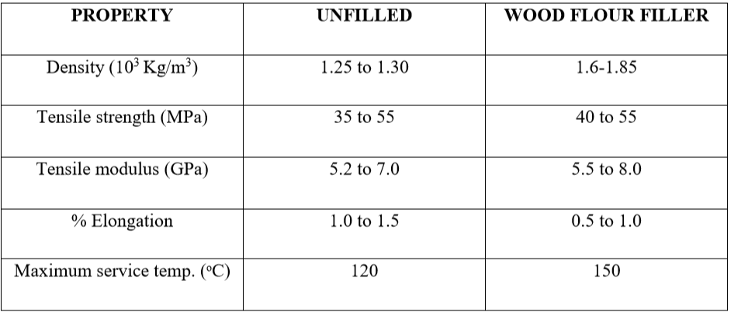

c) POLYESTER PEEK: -
Polyether ether ketone (PEEK) is colourless organic thermoplastic polymer in the polyaryletherketone (PAEK) family, used in engineering applications. It was originally introduced by Victrex PLC, then Imperial Chemical Industries (ICI) in the early 1980s.

PEEK polymers are obtained by step-growth polymerization by the dialkylation of bisphenolate salts. Typical is the reaction of 4,4'-difluorobenzophenone with the disodium salt of hydroquinone, which is generated in situ by deprotonation with sodiumcarbonate. The reaction is conducted around 300 °C in polar aprotic solvents - such as diphenyl sulphone.EEK is a semi-crystalline thermoplastic with excellent mechanical and chemical resistance properties that are retained to high temperatures.

The processing conditions used to mold PEEK can influence the crystallinity and hence the mechanical properties.

The Young's modulus is 3.6 GPa and its tensile strength 90 to 100 MPa.

PEEK has a glass transition temperature of around 143 °C (289 °F) and melts around 343 °C (662 °F). Some grades have a useful operating temperature of up to 250 °C (482 °F).

The thermal conductivity increases nearly linearly with temperature between room temperature and solidus temperature. It is highly resistant to thermal degradation, as well as to attack by both organic and aqueous environments. It is attacked by halogens and strong Bronsted and Lewis acids, as well as some halogenated compounds and aliphatic hydrocarbons at high temperatures.

It is soluble in concentrated sulfuric acid at room temperature, although dissolution can take a very long time unless the polymer is in a form with a high surface-area-to-volume ratio, such as a fine powder or thin film. It has high resistance to biodegradation.
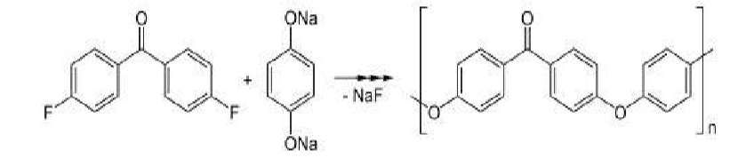

PARTICULATE COMPOSITE AND FIBROUS COMPOSITE

A composite that consists of tiny particles of one material embedded in another material.The particulates can be very small particles (< 0.25 microns), chopped fibers (such as glass), platelets, hollow spheres, or new materials such as bucky balls or carbon nano-tubes.

They provide reinforcement to the matrix material thereby strengthening the material. The combination of reinforcement and matrix can provide for very specific material properties.

Materials in Particulate composite is Metals. Ceramics and Polymers.
Advantages
Provide reinforcement to the matrix material
Improved material properties
Tailored material properties
Manufacturing flexibility
High creep resistance
High tensile strength at elevated temperatures
High toughness
High strength to weight ratio (low density high tensile strength)

Large Particle Composite: -
Some polymeric materials to which fillers have been added are really large- particle composites. The fillers modify or improve the properties of the material. Example of large-particle composite is concrete, which is composed of cement (the matrix), and sand and gravel (the particulates). Particles can have quite a variety of geometries, but they should be of approximately the same dimension in all direction (equated).

For effective reinforcement, the particles should be small and evenly distributed throughout the matrix. The volume fraction of the two phases influences the behavior; mechanical properties are enhanced with increasing particulate content.

Dispersion Particle Composite: -
Dispersion-strengthened means of strengthening materials where in very small particles (usually less than 0.1 µm) of a hard yet inert phase are uniformly dispersed within a load – bearing matrix phase.The dispersed phase may be metallic or nonmetallic, oxide materials are often used.

